**Interior Design Studio Website**

**Submitted By:**

* Team Member: Fariha Shariff
* Roll Number: 2460366
* College Email ID: fariha.shariff@btech.christuniversity.in
* Team Member: Tanya Jaison
* Roll Number: 2460451
* College Email ID: tanya.jaison@btech.christuniversity.in
* Team Member: Christa Fijo
* Roll Number: 260351
* College Email ID: christa.fijo@btech.christuniversity.in

**Course:**  
UI/UX Design Fundamentals

**Instructor Name:**  
Ms.Nagaveena

**Institution:**  
Christ University

**Date of Submission:**  
12/08/2025

**2. Abstract**

This project focuses on designing and developing a multi-page, responsive website for a fictional interior design studio using only HTML5 and CSS3. The goal was to create a professional, visually engaging layout that showcases the studio's services, portfolio, and client testimonials. The website implements modern UI/UX design principles, including CSS Grid, flexbox layouts, and a clean, neutral color palette. Emphasis was placed on aesthetic appeal, accessibility, and device responsiveness. The final product serves as a static yet professional web presence suitable for an interior design business.

**3. Objectives**

* Design a visually appealing and professional UI based on interior design aesthetics.
* Implement a fully responsive layout using only HTML and CSS.
* Use semantic HTML5 structure for better accessibility and SEO.
* Apply CSS styling techniques including Grid, Flexbox, and transitions.
* Create interactive experiences using the CSS checkbox hack and animations.
* Maintain design consistency and brand-oriented color schemes.

**4. Scope of the Project**

* Focused exclusively on **front-end development** using HTML5 and CSS3.
* No use of JavaScript or back-end/server-side technologies.
* Pages developed: Home, Services, Portfolio, Testimonials.
* Designed to support desktop, tablet, and mobile responsiveness.
* Used **open-source fonts**, royalty-free images, and custom styling.
* No third-party CSS frameworks (e.g., Bootstrap) were used.

**5. Tools & Technologies Used**

| **Tool/Technology** | **Purpose** |
| --- | --- |
| HTML5 | Markup structure for content |
| CSS3 | Styling, layout, and responsiveness |
| VS Code | Code editor with live preview extensions |
| Chrome DevTools | Debugging and responsive testing |
| Google Fonts | Custom fonts (Playfair Display, Inter) |
| Unsplash/Pexels | Royalty-free images for visuals |

**6. HTML Structure Overview**

* Used semantic HTML5 elements:
  + <header>, <nav>, <main>, <section>, <footer>
* Website includes the following sections:
  + **Home:** Hero banner, studio philosophy
  + **Services:** Service grid with images and text
  + **Portfolio:** Masonry-style project grid with CSS filters
  + **Testimonials:** CSS-animated carousel with client quotes
* Navigation built using <ul> and <a> tags with consistent anchor links.

**7. CSS Styling Strategy**

* External stylesheet: style.css
* Organized codebase with clear sections (header, main, footer, grid, typography)
* Layout Techniques:
  + CSS Grid for portfolio and services layout
  + Flexbox for navigation and footer
* Responsive Design:
  + Media queries for devices under 768px and 480px
  + Mobile-first design structure
* Advanced CSS Features:
  + CSS variables for colors and fonts
  + Hover effects, smooth transitions
  + Checkbox hack for content filtering

**8. Key Features**

| **Feature** | **Description** |
| --- | --- |
| Responsive Design | Fully adaptable for desktops, tablets, and mobiles |
| Hero Section | Full-width background with elegant typography and call-to-action |
| Service Cards | Grid layout with images, hover effects, and descriptions |
| Portfolio Filtering | CSS-only filter system using checkboxes |
| Animated Testimonials | Sliding carousel animation using CSS keyframes |
| Visual Hierarchy | Fonts, sizes, and spacing reflect design professionalism |
| Accessibility | Contrast, readable font sizes, and semantic tags used |

**9. Challenges Faced & Solutions**

| **Challenge** | **Solution** |
| --- | --- |
| Overlapping sections on small screens | Used Flexbox and media queries to stack elements properly |
| Creating masonry layout without JS | Utilized CSS Grid auto-placement and responsive image sizes |
| Slow animations in testimonials | Adjusted animation duration and timing functions |
| Making filters work without JavaScript | Used CSS checkbox hack for interactive filtering |
| Designing for both dark & light tones | Chose neutral background with one bold accent |

**10. Outcome**

* Aesthetic, clean, and modern website structure achieved.
* Functioning multi-page layout developed using only HTML and CSS.
* Improved understanding of grid systems, media queries, and semantic HTML.
* Learned how to use visual hierarchy, white space, and branding effectively.
* Delivered a responsive UI design suitable for real-world application.

**11. Future Enhancements**

* Add JavaScript to improve filtering and add animations.
* Implement a working contact form with backend integration.
* Add interactive components like modal popups or image sliders.
* Create dark/light theme toggle with CSS variables and JavaScript.
* Use GSAP or ScrollMagic for scroll-triggered animations.

**12. Sample Code Snippet**

**1) Code for index.html**

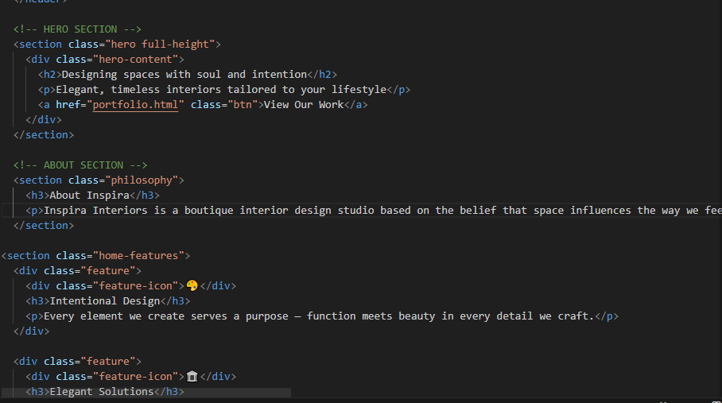

2) Code for portfolio.html

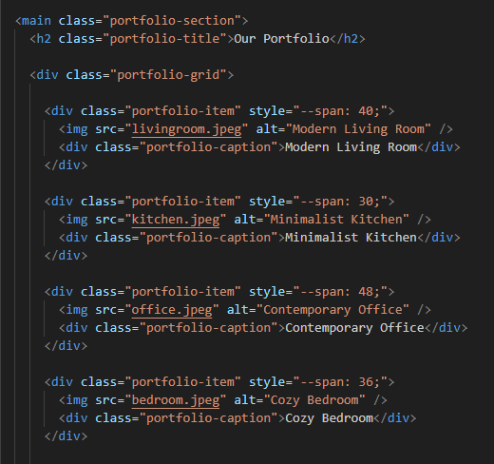

3) Code for services.html

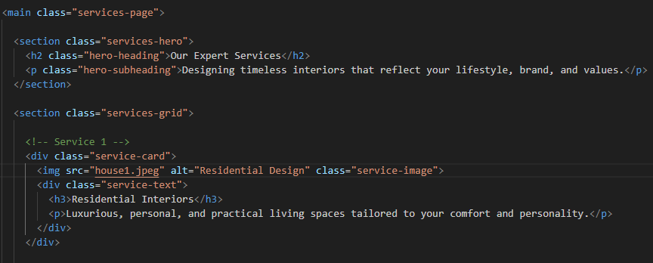

4) Code for testimonials.html

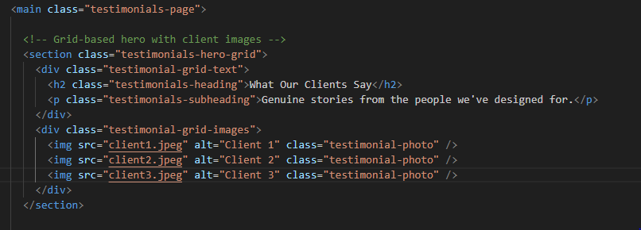

Code for css part of the program-

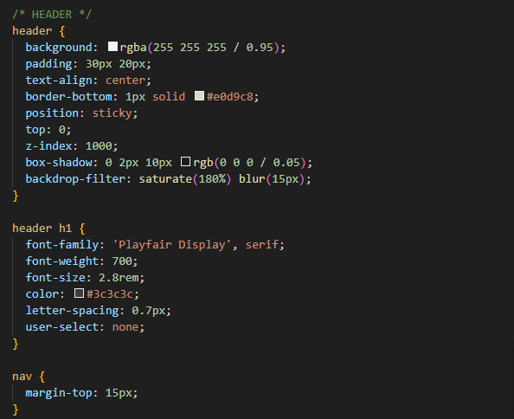

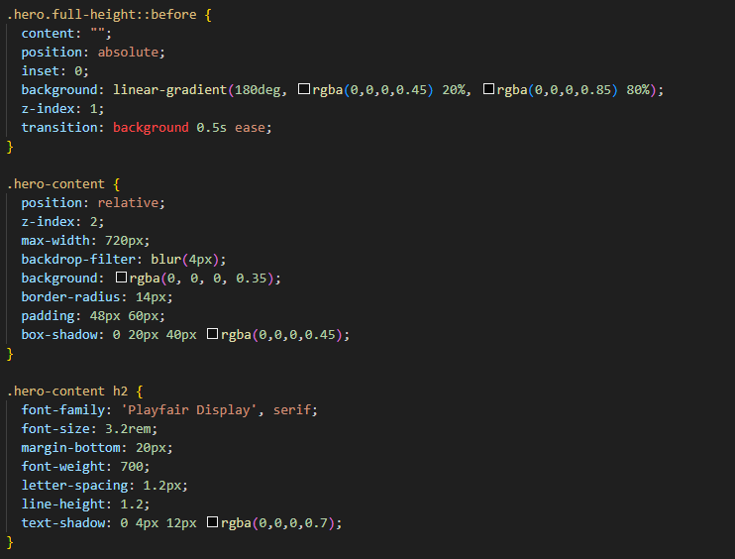

**13. Screenshots of Final Output**

*Attach screenshots here with device labels and captions:*

* Desktop View – Home Page

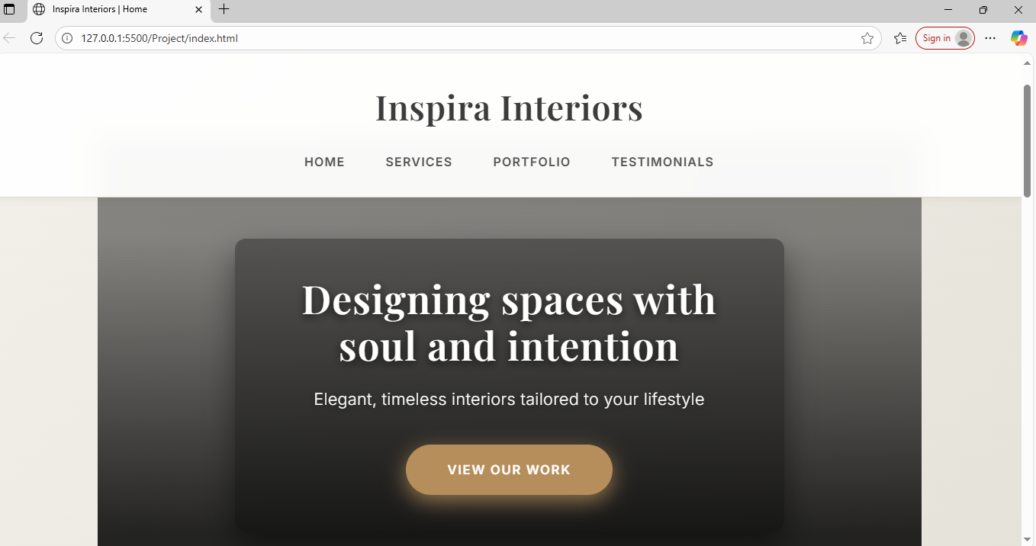

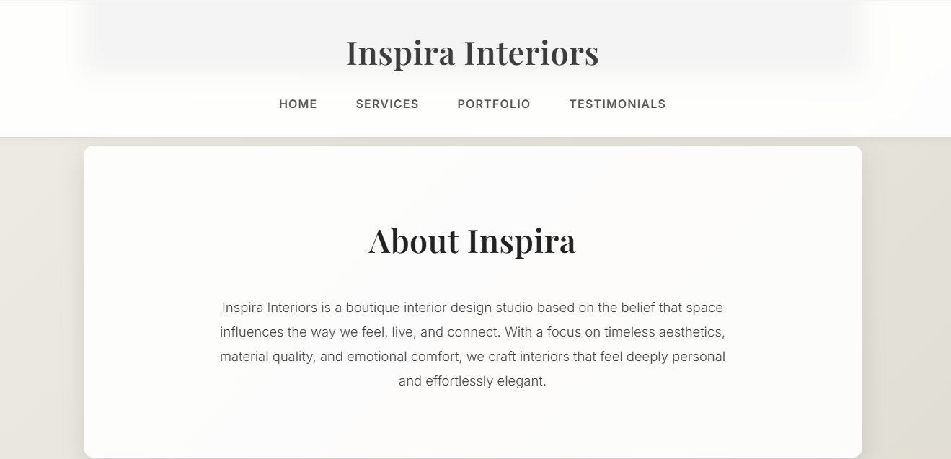

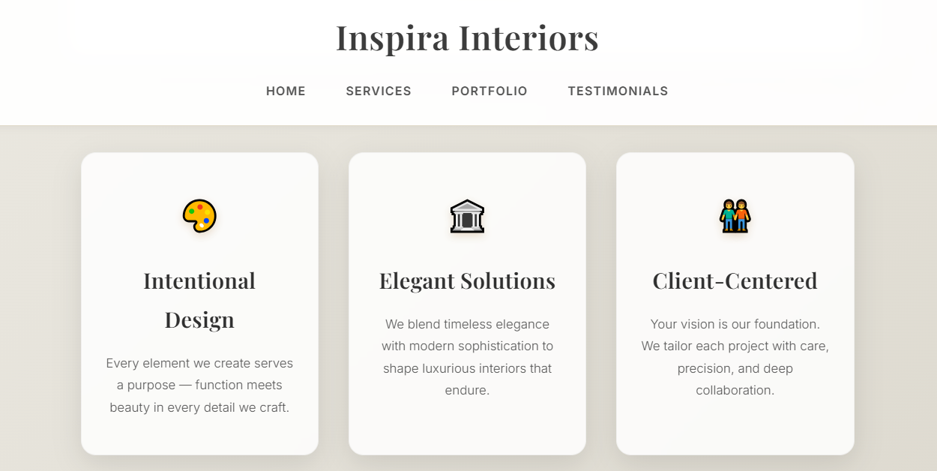

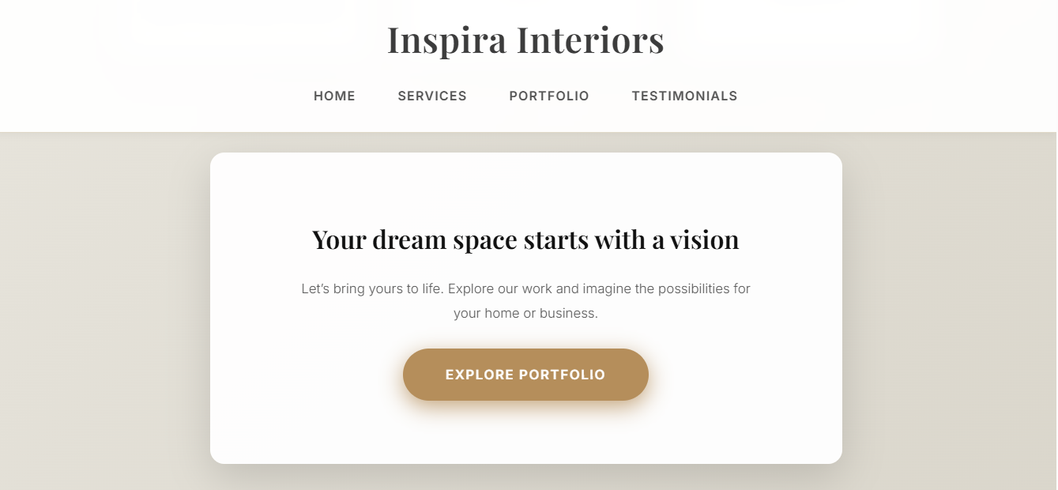

* Tablet View – Services Grid

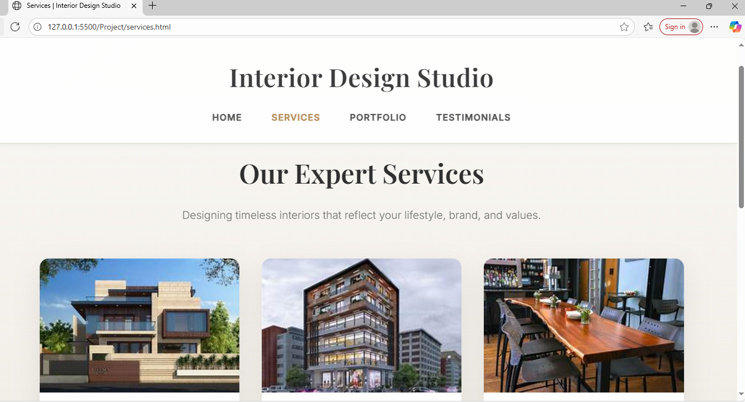

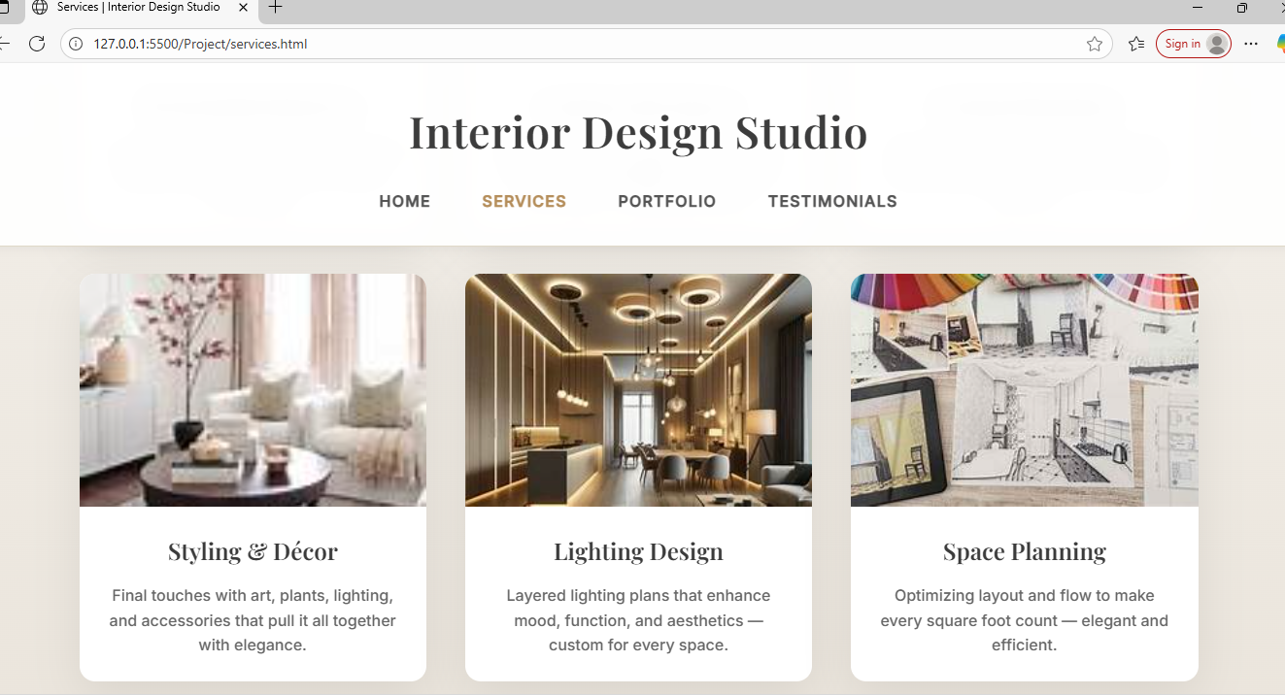

* Mobile View – Responsive Navigation bar

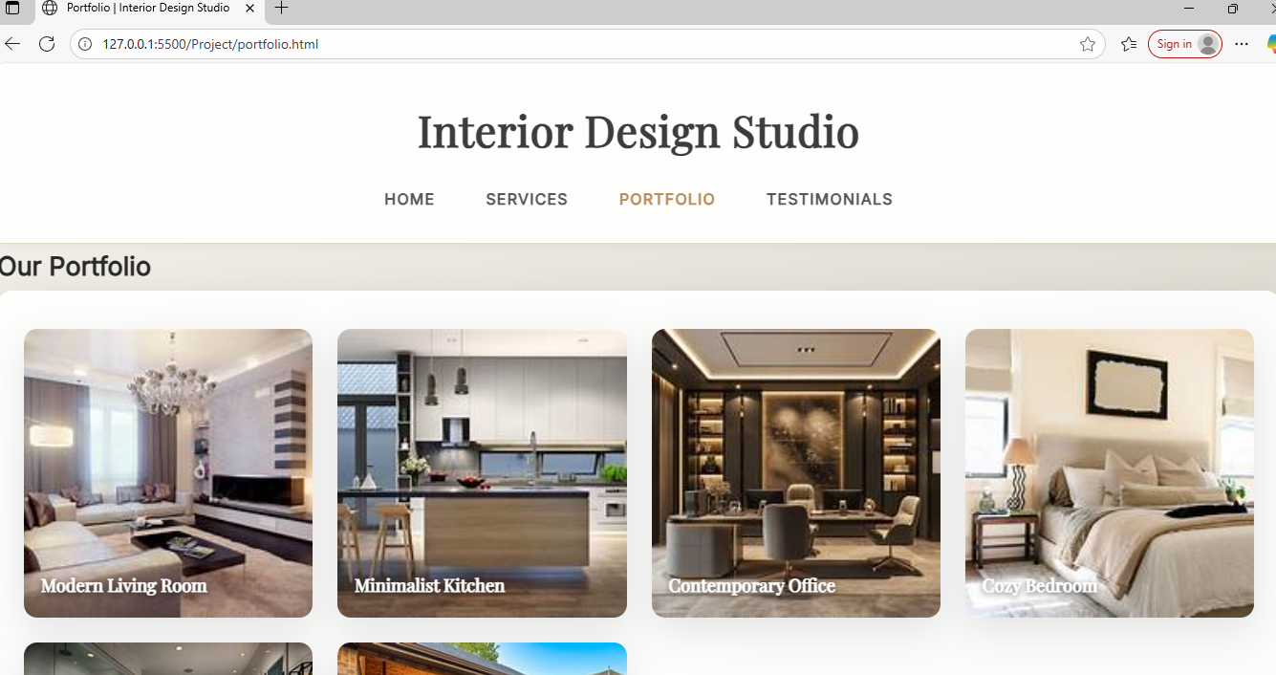

* Portfolio Filtering Demo

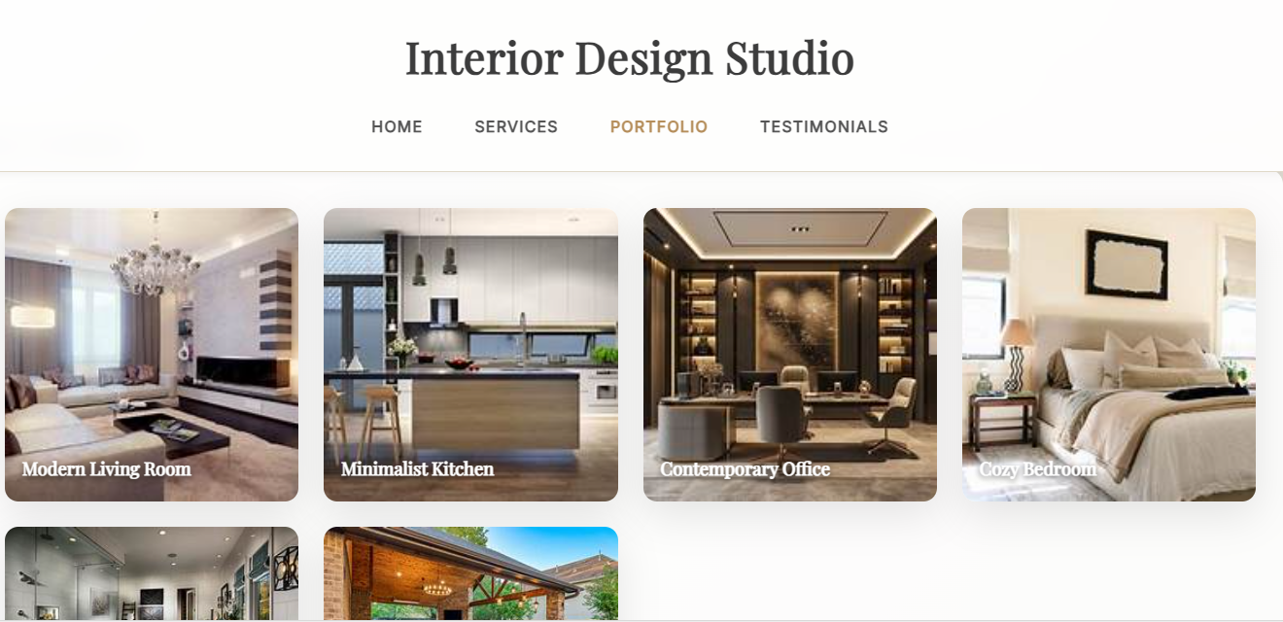

* Testimonials Carousel in motion

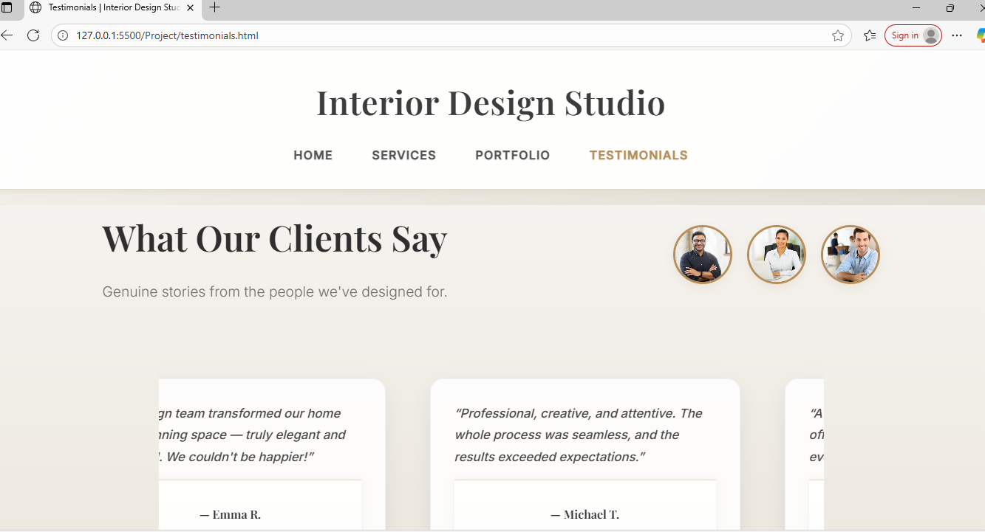

**14. Conclusion**

This project involved designing and building a professional, multi-page front-end website for an interior design studio. It helped solidify concepts of UI/UX, responsive design, semantic HTML, and CSS layout systems. From hero sections to interactive service cards, the design emphasizes elegance and usability. Building this project with no JavaScript pushed creative use of CSS-only solutions. It was an enriching experience that deepened our understanding of layout design, brand consistency, and user-focused web experiences.

**15. References**

* L&T LMS: <https://learn.lntedutech.com/Landing/MyCou>rse
* Unsplash: [https://unsplash.com](https://unsplash.com/)
* Google Fonts: [https://fonts.google.com](https://fonts.google.com/)
* MDN Web Docs: https://developer.mozilla.org